ULTRASONIC THICKNESS MEASUREMENT REPORT
Company/Client: NCOC N.V. |  |  | Project: ESKENE WEST KARABATAN |  |  |  |  | Location: Gas 1 Tr 1
Line No/Tag No:  A1-3201-CD-073-6”-A17-WN |  |  | Component examined | Material |  | A333 Gr 3 |  | Probe sensitivity calibration
Procedure No:  QP-11-UTT-Q01 Rev 01 |  |  | Component examined | Día X Nominal Thickness |  | 4” x 11.13 mm |  | Probe S/N |  | 925365
 |  |  | Component examined | Operating Temp |  | Ambient |  | Angle |  | 0º
Manufacturing Code/Acceptance Standard:  ASME B31.3 / Client Specific |  |  | Reference Calibration Block Details | Block |  | CS Step wedge |  | Frequency |  | 5 MHz
 |  |  | Reference Calibration Block Details | Range |  | (6.25-25 mm) |  | size |  | 11 mm
Method: Contact |  |  | Reference Calibration Block Details | Accuracy |  | 0.025 mm |  | Crystal |  | Dual
Surface condition: Coated |  |  | Reference Calibration Block Details | Temperature |  | +1 |  | Reference sensitivity |  | 2nd backwall reflection to 80% FSH
Couplant: Gel |  |  | Correction factors |  |  | n/a |  | Scan Sensitivity |  | Reference dB
S. No | Equipment/  Material Name | Manufacturer |  |  | Serial No |  | Calibration certificate No |  | Calibration Expiry date
 | A-scan UT | OLYMPUS DL-38 |  |  | 171421601 |  | 2113237 |  | 01-04-2018
 | Step wedge calibration block | OLYMPUS |  |  | 145414 |  | - |  | -
Job description:

- UT scanning has been carried out on 4”Ø pipe at 3-6-9 O’clock whit width 15 cm and spot reading taken on around the pipe.

Legend:
FSH: Full Screen Height, N/A: Not Applicable

DETAILS AND RESULTS
A1-3201-CD-073-6”-A17-WN

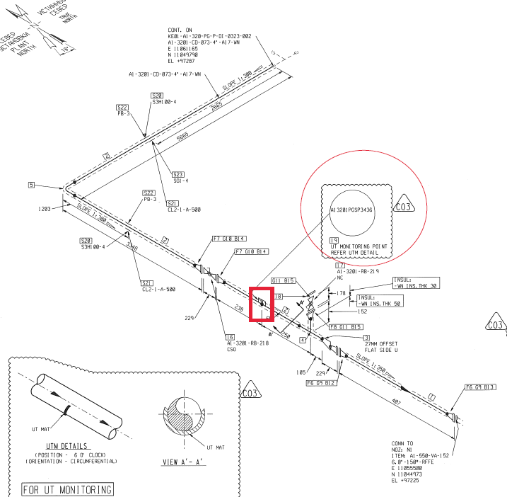

S/NO | Inspection date | Item description | DIA(Ø) | 12 o’clock  (Top) | 3 o’clock  (West) | 6 o’clock  (Bottom) | 9 o’clock  (East)
1 | 28-10-17 | Pipe | 4” | 10.7 | 10.4 | 10.8 | 10.8
2 | 08-12-17 | Pipe | 4” | 10.9 | 10.4 | 10.7 | 10.9
3 | 15-03-2018 | Pipe | 4” | 10.7 | 10.4 | 10.7 | 10.8

APPROVALS:
Operator UT L-II:  cert. No 86-09-17  exp. date 11.09.2020 | Name: ......RYSKULOV ..NURTAS......... | Signature:............................................... | Date:…………………………..
Supervisor UT L II:  cert. : C/625  expiry date 08.07.2018: | Name: ..............SUDHAGAR.................... | Signature:............................................... | Date: …………………………
Client Representative: | Name:……………………………………… | Signature:............................................... | Date: …………………………
Minimum thickness observed on 8.50 mm

